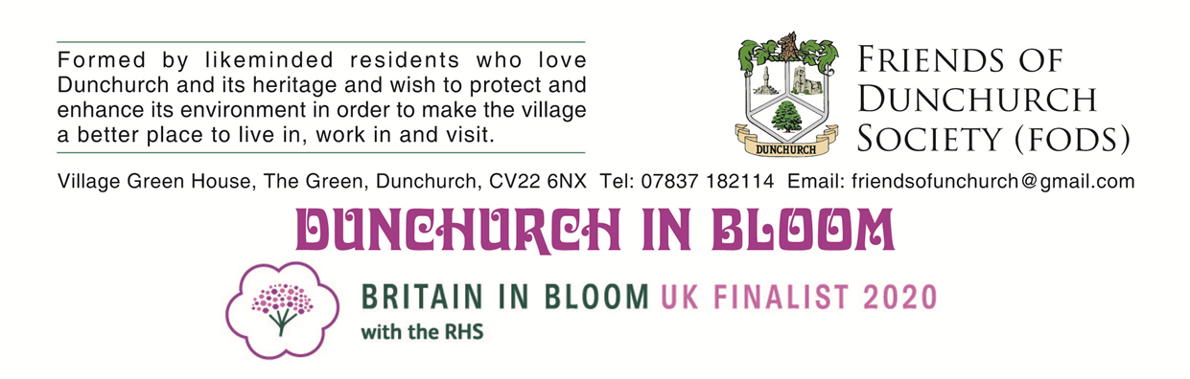
BLOOMING BARROWS

SUMMER PLANTING
THIS YEAR FODS ARE PREPARING TO BRING DUNCHURCH IN BLOOM
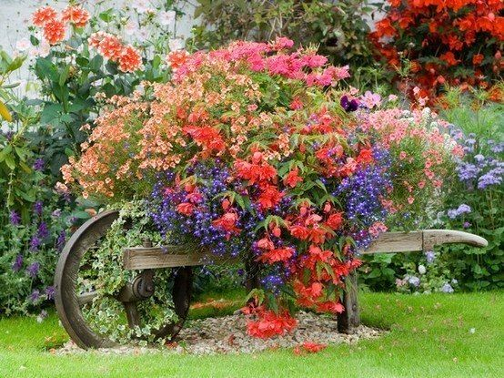
PLANTING SCHEME TO WHERE YOU LIVE!
AT NO COST TO YOU
You just provide the plants of your choice
BLOOMING BARROWS
ORDER
YOURS NOW!

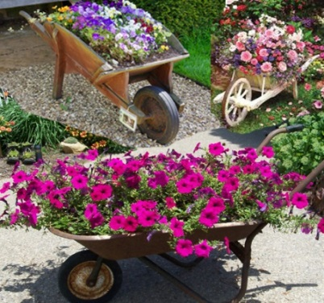
Dunchurch has been selected to represent the entire Heart of England Region in the Britain in Bloom 2020 national Finals event in the Large Village category.
This follows the success achieved by our Dunchurch community in the 2019 regional event when the village won major awards, the best of 7 counties – Warwickshire, Worcestershire, Herefordshire, Staffordshire, West Midlands, Gloucestershire and Shropshire and a special achievement in the large village category.
Planting plans for 2020
FODS are preparing to extend the village 2019 Dunchurch in Bloom planting scheme by inviting growing groups formed by residents/organisations in all parts of the village to apply to FODS to be part of our Dunchurch in Bloom ‘Blooming Barrows’ project – Grow Social.
Blooming Barrows
FODS are converting wheelbarrows for use as plant growing containers. Residents Groups/Organisations are invited to apply for a FODS wheelbarrow which will be delivered to you on loan with suitable compost for groups to plant out and care for and to be enjoyed by the growing group neighbours and the local community at large.
Costs
The costs of the wheelbarrow and compost will be funded by FODS. Growing groups only need to purchase the plants of their choice – flowers, herbs or why not a meal barrow? And plant with vegetables or salad
Locations
Blooming Barrows can be located anywhere for the convenience and enjoyment of the growing group and the wider community. This is a lovely opportunity for you and your fellow group growers to be involved where you live in Dunchurch in Bloom.
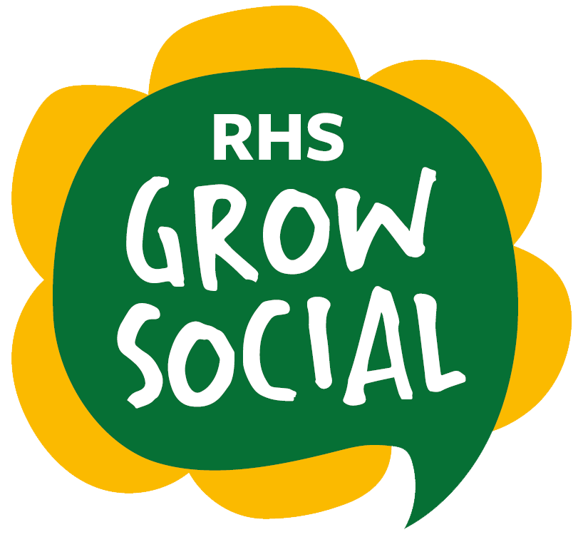
Expertise
You do not need to have green fingers to be involved - FODS volunteer dedicated gardeners will be at hand, if required, to advise. A FODS gardening guide booklet will be provided with the barrow
Make Dunchurch a better place to live in work in and visit
Bring joy and delight to your growing group, neighbourhood and immediate community
PLEASE APPLY FOR YOUR BLOOMING BARROW NOW WHILE STOCKS LAST!
To register your interest or for more information about having a Blooming Barrow please contact Blooming Barrow coordinator Sue Protheroe. Email: fodnews1@gmail.com Tel: 07477 670394

