
DUNCHURCH IN BLOOM WATER SAVING PROJECT
CAN YOU HELP?
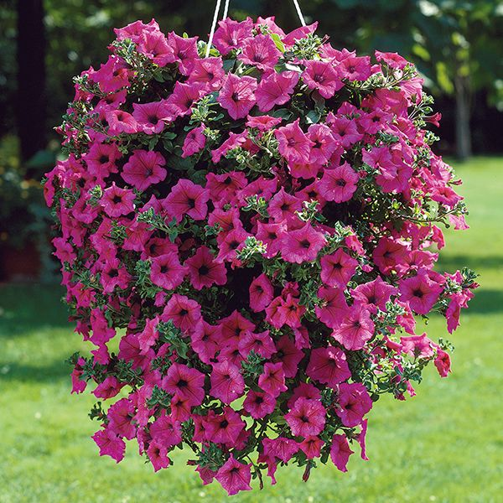


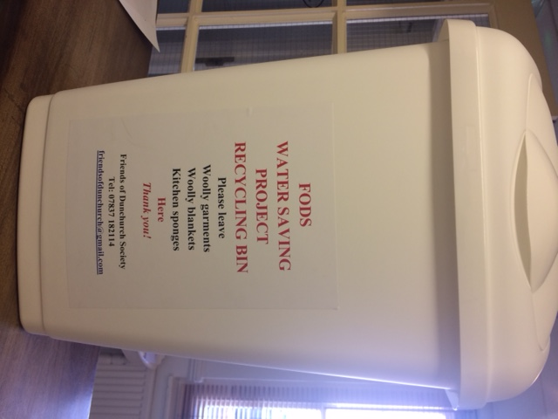
Our research has revealed that we can reduce water use in plant containers by up to 80%!
Lining each container with woollen garments or blankets and placing recycled kitchen sponges in the container bottom saves water
and watering time.
Our growers will adopt this policy when preparing village containers for summer planting.
PLEASE DONATE
YOUR OLD WOOLLY JUMPERS / BLANKETS AND SPONGES FOR RECYCLING
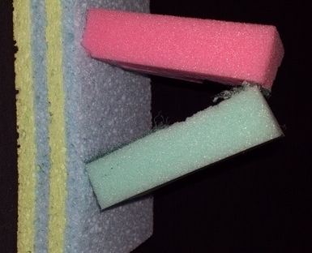
FODS
RECYCLING BIN
IS LOCATED IN THE LIBRARY

Tues, Thurs, Friday 10 till 6.30 & Saturday 10 till 1pm
(Thank you DPC)
www.friendsofdunchurchsociety.org
Kitchen sponges
High wool content is best
